### 选择年份，点击查询，获取【行政区】（各县）评价数据，用于地图展示【done】

//选择年份，点击查询，获取各县评价数据，用于地图展示

"承载力类别等级": "0",   -----不超载  
"达标颜色": "#0x0000FF"  
  
  
"承载力类别等级": "1",   ----- 临界超载  
"达标颜色": "#FCD209"  
  
  
"承载力类别等级": "2",   -------超载区  
"达标颜色": "#FF0000"

参数：water_body_id, 年份 string

"attributes": {

"targetList": [{

“行政区_id”: uuid,

"SUPER_OBJ_ID": "210521",

"承载力类别等级": "0",

"达标颜色": "#00FF00"

},{

“行政区_id”: uuid,

"SUPER_OBJ_ID": "210504",

"承载力类别等级": "1",

"达标颜色": "#00FF00"

},{

"SUPER_OBJ_ID": "210381",

"承载力类别等级": "1",

"达标颜色": "#00FF00"

},{

"SUPER_OBJ_ID": "210421",

"承载力类别等级": "2",

"达标颜色": "#00FF00"

}]}

接口方法

getXZQDataList (water_body_id, 年份)

返回结果

{"success":true,"message":null,"title":null,"attributes":{"targetList":[{"行政区_id":"A5E9A4AC34BA4317A5377B901B4C93D6","SUPER_OBJ_ID":"211000","承载力类别等级":"0","达标颜色":"#0x0000FF"}]}}

### 2、行政区承载力情况统计表

/**行政区承载力情况统计表*/

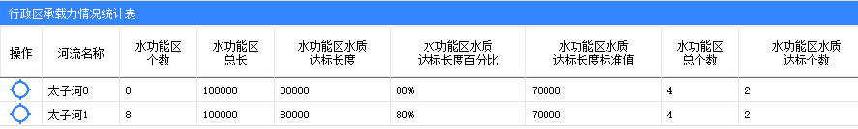

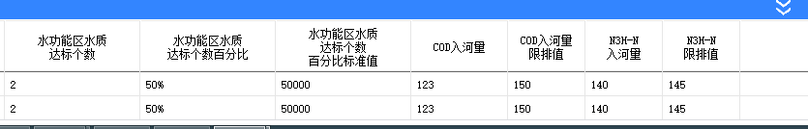

**参数，water_body_id,行政区_id，年份**

返回值

{

"message": "信息查询成功。",

"nodeList": [

{

"code": "RIVER000", --河流id uuid

"name": "太子河0", --河流名称

"totalCount": "8", --水功能区个数

"totalLength":"100000", --水功能区总长

"attainedLength":"80000", --水功能区达标长度

"lengthPercent":"80%", --水功能区长度达标百分比

"standardLength":"70000", --暂不做

"functionCount":"4", --暂不做

"attainedCount":"2", --水功能区水质达标个数

"attainedPercent":"50%", --水功能区个数达标百分比

"standardValue":"50000", --暂不做

"cod":"123", --cod入河量总和

"limitCod":"150", --COD河流限排值

"inputValue":"140", --氨氮入河量总和

"limitValue":"145", --氨氮河流限排值

"x": "123.31279", --经度

"y": "41.105675" --纬度

},

{

"code": "RIVER001",

"name": "太子河1",

"totalCount": "8",

"totalLength":"100000",

"attainedLength":"80000",

"lengthPercent":"80%",

"standardLength":"70000",

"functionCount":"4",

"attainedCount":"2",

"attainedPercent":"50%",

"standardValue":"50000",

"cod":"123",

"limitCod":"150",

"inputValue":"140",

"limitValue":"145",

"x": "123.511276",

"y": "41.297588"

}],

"propFields": [

{

"fieldKey": "code",

"fieldName": "河流编码",

"colWidth": "80",

"isMainKey": "0"

},

{

"fieldKey": "name",

"fieldName": "河流名称",

"colWidth": "80",

"isMainKey": "1"

},

{

"fieldKey": "totalCount",

"fieldName": "水功能区^个数",

"colWidth": "80",

"isMainKey": "1"

},

{

"fieldKey": "totalLength",

"fieldName": "水功能区^总长",

"colWidth": "80",

"isMainKey": "1"

},

{

"fieldKey": "attainedLength",

"fieldName": "水功能区水质^达标长度",

"colWidth": "120",

"isMainKey": "1"

},

{

"fieldKey": "lengthPercent",

"fieldName": "水功能区水质^达标长度百分比",

"colWidth": "140",

"isMainKey": "1"

},

{

"fieldKey": "standardLength",

"fieldName": "水功能区水质^达标长度标准值",

"colWidth": "140",

"isMainKey": "1"

},

{

"fieldKey": "functionCount",

"fieldName": "水功能区^总个数",

"colWidth": "80",

"isMainKey": "1"

},

{

"fieldKey": "attainedCount",

"fieldName": "水功能区水质^达标个数",

"colWidth": "140",

"isMainKey": "1"

},

{

"fieldKey": "attainedPercent",

"fieldName": "水功能区水质^达标个数百分比",

"colWidth": "140",

"isMainKey": "1"

},

{

"fieldKey": "standardValue",

"fieldName": "水功能区水质^达标个数^百分比标准值",

"colWidth": "140",

"isMainKey": "1"

},

{

"fieldKey": "cod",

"fieldName": "COD入河量",

"colWidth": "100",

"isMainKey": "1"

},

{

"fieldKey": "limitCod",

"fieldName": "COD入河量^限排值",

"colWidth": "80",

"isMainKey": "1"

},

{

"fieldKey": "inputValue",

"fieldName": "N3H-N^入河量",

"colWidth": "80",

"isMainKey": "1"

},

{

"fieldKey": "limitValue",

"fieldName": "N3H-N^限排值",

"colWidth": "80",

"isMainKey": "1"

},

{

"fieldKey": "x",

"fieldName": "经度",

"colWidth": "80",

"isMainKey": "0"

},

{

"fieldKey": "y",

"fieldName": "纬度",

"colWidth": "80",

"isMainKey": "0"

}],

"responseSts": 0,

"totalCount": 2

}

### 3 河流水功能区水质达标率及污染物入河量情况统计表

/**河流水功能区水质达标率及污染物入河量情况统计表*/

**参数： water_body_id,行政区_id, 年份， 河流_id**

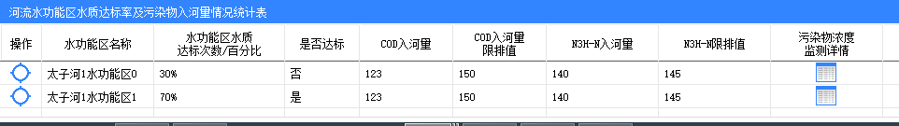

{

"message": "信息查询成功。",

"nodeList": [

{

"code": "RIVER001", --河流id uuid

"name": "太子河1", --河流名称

"funCode": "FUNCTION000", --水功能区id uuid

"funName": "太子河1水功能区0",--水功能区名称

"attainedPercent": "30%", --水功能区达标次数/百分比

"isAttained":"否", --参考3.2 单个水功能区是否达标

"cod":"123", --COD入河量

"limitCod":"150", --暂不考虑

"inputValue":"140", --氨氮入河量

"limitValue":"145", --暂不考虑

"monDetail":"",

"x": "123.31279", --经度

"y": "41.105675" --纬度

},

{

"code": "RIVER001",

"name": "太子河1",

"funCode": "FUNCTION001",

"funName": "太子河1水功能区1",

"attainedPercent": "70%",

"isAttained":"是",

"cod":"123",

"limitCod":"150",

"inputValue":"140",

"limitValue":"145",

"monDetail":"",

"x": "123.511276",

"y": "41.297588"

}],

"propFields": [

{

"fieldKey": "code",

"fieldName": "河流编码",

"colWidth": "80",

"isMainKey": "0"

},

{

"fieldKey": "name",

"fieldName": "河流名称",

"colWidth": "80",

"isMainKey": "0"

},

{

"fieldKey": "funCode",

"fieldName": "水功能区^编码",

"colWidth": "80",

"isMainKey": "0"

},

{

"fieldKey": "funName",

"fieldName": "水功能区名称",

"colWidth": "120",

"isMainKey": "1"

},

{

"fieldKey": "attainedPercent",

"fieldName": "水功能区水质^达标次数/百分比",

"colWidth": "140",

"isMainKey": "1"

},

{

"fieldKey": "isAttained",

"fieldName": "是否达标",

"colWidth": "80",

"isMainKey": "1"

},

{

"fieldKey": "cod",

"fieldName": "COD入河量",

"colWidth": "100",

"isMainKey": "1"

},

{

"fieldKey": "limitCod",

"fieldName": "COD入河量^限排值",

"colWidth": "100",

"isMainKey": "1"

},

{

"fieldKey": "inputValue",

"fieldName": "N3H-N入河量",

"colWidth": "120",

"isMainKey": "1"

},

{

"fieldKey": "limitValue",

"fieldName": "N3H-N限排值",

"colWidth": "120",

"isMainKey": "1"

},

{

"fieldKey": "monDetail",

"fieldName": "污染物浓度^监测详情",

"colWidth": "120",

"isMainKey": "-1"

},

{

"fieldKey": "x",

"fieldName": "经度",

"colWidth": "80",

"isMainKey": "0"

},

{

"fieldKey": "y",

"fieldName": "纬度",

"colWidth": "80",

"isMainKey": "0"

}],

"responseSts": 0,

"totalCount": 2

}

### 4、水功能区水质达标率及污染物入河量详情

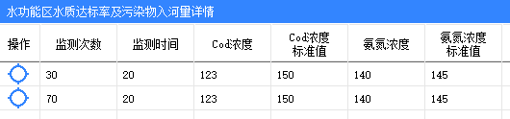

参数：water_body_id,年份，行政区id，河流id，水功能区id（对应的监控断面）

/**水功能区水质达标率及污染物入河量详情*/

{

"message": "信息查询成功。",

"nodeList": [

{

"code": "FUNCTION000", --uuid

"name": "太子河水功能区0",

"monitorCount": "30", --监测次数序号（第xx次）

"monitorTime":"20", --监测日期（yyyy-mm-dd hh:mm:ss）

"codValue":"123", --cod浓度（水质指标值）

"codStandardValue":"150", --cod 三类水质标准值

"anValue":"140", --氨氮浓度（水质指标值）

"anStandardValue":"145", --氨氮 三类水质标准值

"x": "123.31279", --经度

"y": "41.105675" --纬度

},

{

"code": "FUNCTION001",

"name": "太子河水功能区0",

"monitorCount": "70",

"monitorTime":"20",

"codValue":"123",

"codStandardValue":"150",

"anValue":"140",

"anStandardValue":"145",

"x": "123.511276",

"y": "41.297588"

}],

"propFields": [

{

"fieldKey": "code",

"fieldName": "水功能区^编码",

"colWidth": "80",

"isMainKey": "0"

},

{

"fieldKey": "name",

"fieldName": "水功能区^名称",

"colWidth": "80",

"isMainKey": "0"

},

{

"fieldKey": "monitorCount",

"fieldName": "监测次数",

"colWidth": "80",

"isMainKey": "1"

},

{

"fieldKey": "monitorTime",

"fieldName": "监测时间",

"isSortField": "true",

"isAsc": "1",

"colWidth": "80",

"isMainKey": "1"

},

{

"fieldKey": "codValue",

"fieldName": "Cod浓度",

"colWidth": "80",

"isMainKey": "1"

},

{

"fieldKey": "codStandardValue",

"fieldName": "Cod浓度^标准值",

"colWidth": "80",

"isMainKey": "1"

},

{

"fieldKey": "anValue",

"fieldName": "氨氮浓度",

"colWidth": "80",

"isMainKey": "1"

},

{

"fieldKey": "anStandardValue",

"fieldName": "氨氮浓度^标准值",

"colWidth": "80",

"isMainKey": "1"

},

{

"fieldKey": "x",

"fieldName": "经度",

"colWidth": "80",

"isMainKey": "0"

},

{

"fieldKey": "y",

"fieldName": "纬度",

"colWidth": "80",

"isMainKey": "0"

}],

"responseSts": 0,

"totalCount": 2

};

### 5、水功能区排污口污染物入河量详情

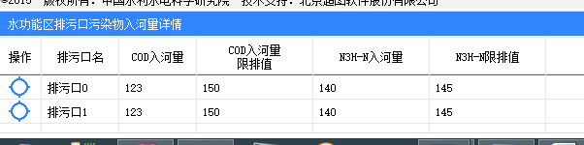

参数：water_body_id, 年份，行政区id，河流id，水功能区id

/**水功能区排污口污染物入河量详情*/

{

"message": "信息查询成功。",

"nodeList": [

{

"code": "FUNCTION000", --水功能区uuid

"name": "太子河水功能区0", --水功能区名称

"pollutionCode":"POLLUTION000", --排污口uuid

"pollutionName": "排污口0", --排污口名称

"isAttained":"否", --不处理

"cod":"123", --cod入河量

"limitCod":"150", --不处理

"inputValue":"140", --氨氮入河量

"limitValue":"145", --不处理

"monDetail":"", --不处理

"x": "123.31279", --排污口经度

"y": "41.105675" --排污口纬度

},

{

"code": "FUNCTION001",

"name": "太子河水功能区1",

"pollutionCode":"POLLUTION001",

"pollutionName": "排污口1",

"isAttained":"是",

"cod":"123",

"limitCod":"150",

"inputValue":"140",

"limitValue":"145",

"monDetail":"",

"x": "123.511276",

"y": "41.297588"

}],

"propFields": [

{

"fieldKey": "code",

"fieldName": "水功能区^编码",

"colWidth": "80",

"isMainKey": "0"

},

{

"fieldKey": "name",

"fieldName": "水功能区^名称",

"colWidth": "80",

"isMainKey": "0"

},

{

"fieldKey": "pollutionCode",

"fieldName": "排污口编码",

"colWidth": "120",

"isMainKey": "0"

},

{

"fieldKey": "pollutionName",

"fieldName": "排污口名",

"colWidth": "80",

"isMainKey": "1"

},

{

"fieldKey": "cod",

"fieldName": "COD入河量",

"colWidth": "80",

"isMainKey": "1"

},

{

"fieldKey": "limitCod",

"fieldName": "COD入河量^限排值",

"colWidth": "120",

"isMainKey": "1"

},

{

"fieldKey": "inputValue",

"fieldName": "N3H-N入河量",

"colWidth": "120",

"isMainKey": "1"

},

{

"fieldKey": "limitValue",

"fieldName": "N3H-N限排值",

"colWidth": "120",

"isMainKey": "1"

},

{

"fieldKey": "x",

"fieldName": "经度",

"colWidth": "80",

"isMainKey": "0"

},

{

"fieldKey": "y",

"fieldName": "纬度",

"colWidth": "80",

"isMainKey": "0"

}],

"responseSts": 0,

"totalCount": 2

}

### 6、县区域水资源承载力气泡数据

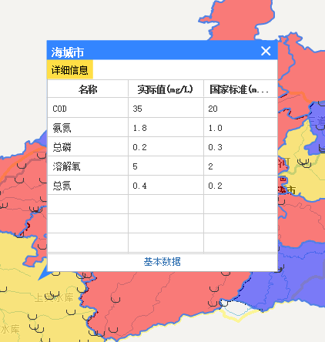

参数：water_body_id，年份，行政区id

返回值，

|  |  |  |
| --- | --- | --- |
| 名称 | 评估值 | 限值 |
| Cod入河量 |  |  |
| 氨氮入河量 |  |  |
| 水功能区长度达标率 |  |  |
| 水功能区个数达标率 |  |  |

/**县区域水资源承载力气泡数据*/

{

"message": "信息查询成功。",

"responseSts": 0,

"surveyData": [

{

"resultInfoHeaderList": [{

"showValue": "名称",

"decimalDigits": 0,

"code": "name",

"colWidth": 0

},

{

"showValue": "实际值(mg/L)",

"decimalDigits": 0,

"code": "value",

"colWidth": 0

},

{

"showValue": "国家标准(mg/L)",

"decimalDigits": 0,

"code": "standard",

"colWidth": 0

}],

"detailType": "detailInfo",

"label": "详细信息",

"resultInfoDetailList": [{

"name": "COD",

"value": "35",

"standard":"20"

},

{

"name": "氨氮",

"value": "1.8",

"standard":"1.0"

},

{

"name": "总磷",

"value": "0.2",

"standard":"0.3"

},

{

"name": "溶解氧",

"value": "5",

"standard":"2"

},

{

"name": "总氮",

"value": "0.4",

"standard":"0.2"

}]

}]

}

### 7. 获取年份列表【done】

**方法：**

**public** String getSZYYearList(String water_body_id)

返回值

{"success":true,"message":null,"title":null,"attributes":{"targetList":[{"year":"2016"},{"year":"2010"}]}}

### 8. 排污口标绘

getSZYPWKObj（water_body_id）

### 9. 水功能区目标水质(水质评价补充 )

方法：getWaterFounctionWaterregimen（water_body_id）

返回：

{

"success": true,//请求成功为true,登陆失败为false

"message": null,//不成功时的提示信息

"title": null,//提示信息标题

"attributes": { //附带的内容

"targetList":[{

"id":"xxx",//水功能区_ID

super_obj_id:

"name":"xxx",水功能区名称

目标水质名称:

目标水质颜色:

}]

}

}